We will look at:

* **SNS**: notification service
* **cloud watch**: alert level monitoring or event level monitoring
* How to send emails using an **SES** service. and
* if time permits we would also go ahead and set up a **cloud trail** and we will have what it enabled in all our regions and we collect it into a single extreme bucket and any choice of our region.

**SNS (simple notification service)**

* it is one of the easiest notification service that you can configure in the cloud whether you are going to publish messages to one application or you are going to reach messages to thousands of endpoints or mobile phones or any other endpoints that you can imagine like IOT devices
* It works on the pub/sub model that is publish and subscribe.

So, anybody wants to who wants to receive your message has to subscribe to your topic mandatorily otherwise they will not be able to receive those messages.

Ex you can think of it like email groups that we might subscribe to or any website offers or **e-commerce portals will give you subscribe to my offers then you will get the coupons on your email** this is how the functionality is built at the back end.

**SNS architecture.**

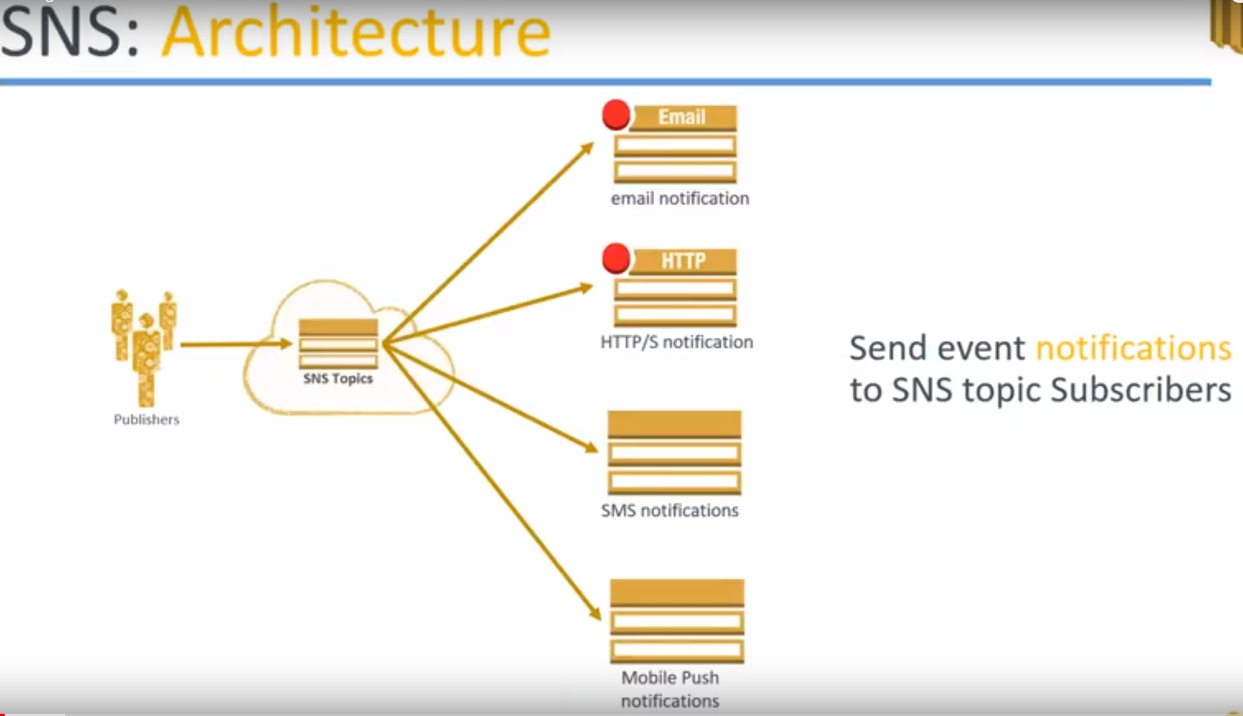

1. You have **publisher**, who is creating the message that needs to be delivered to a lot of people. Let us call them as publishers now.

They are going to publish their message to the **SNS topic.**

**2) SNS Topics:**

* Ex of topic: coupons which will be giving new offers.
* another topic might be for offers on existing products…. when this is all products level
* for a travel portal they will be offering discounts on holiday packages

You can have n number of topics in your SNS groups.

**3.) endpoints**

Then come to the endpoints. you have multiple endpoints or multiple ways of sending messages to your end points...

**Ex:**

* email notification. you can send all your subscribers on email.
* you can send an HTTP or HTTPS notification. This can be useful for your applications to consume the message when you're sending it through HTTP.
* Sending an SMS or OTP kind of notifications.
* Mobile push notifications, which you get on your Android or iPhone mobile.

So these are the two different types of ways you can send your message to your endpoints...

**SNS benefits** 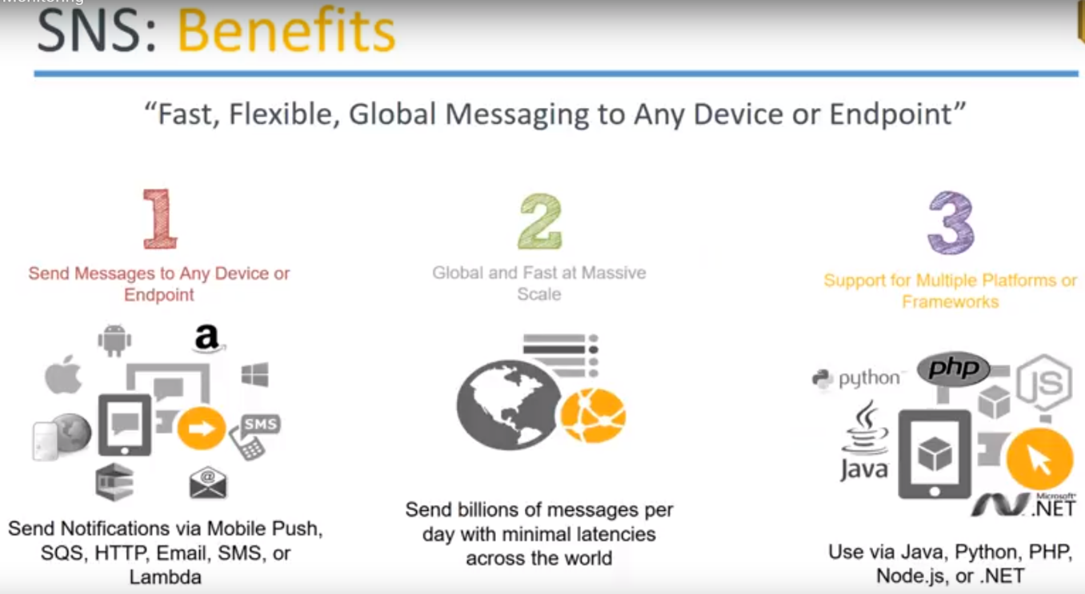

1. You can send message to any device or end point

Like: mobile push notification, SQS, Lambda, HTTP, SMS email.

**Example:**

* A new processing image has been done by replicate cluster and then you want to notify the data scientist so once the clusters finished processing ..,then you will configure an email service.
* if you want a batch load across processing is completed then you want to do the second level of processing then you will trigger the lambda then the lambda will pick up the process two files and go ahead and do it so.

what type of notification that you choose is absolutely depend upon your application and you have to configure the based on that.

2.) This is a service that scales automatically whether you are sending too few people or spending to a lot of endpoints. This service is global scale and you can send to anybody.

**For example:** I want to send a few SMS to people in the United States.

All I have to do is subscribe that mobile numbers into my SNS topic and I can push an SMS or push notification to their mobile phones are sitting in any other part of the world.

3.) multiple platforms are given to you for writing your SMS messages.

You can write it in a Programmatic way or you can use a dashboard and hand write or hand code you or message also.

When you are choosing a programmatic way through multiple languages Java ,Python ,dotnet, node.js all of them are supported.

You can go ahead and use any of those frameworks to send you push notifications

**SNS Use cases:**

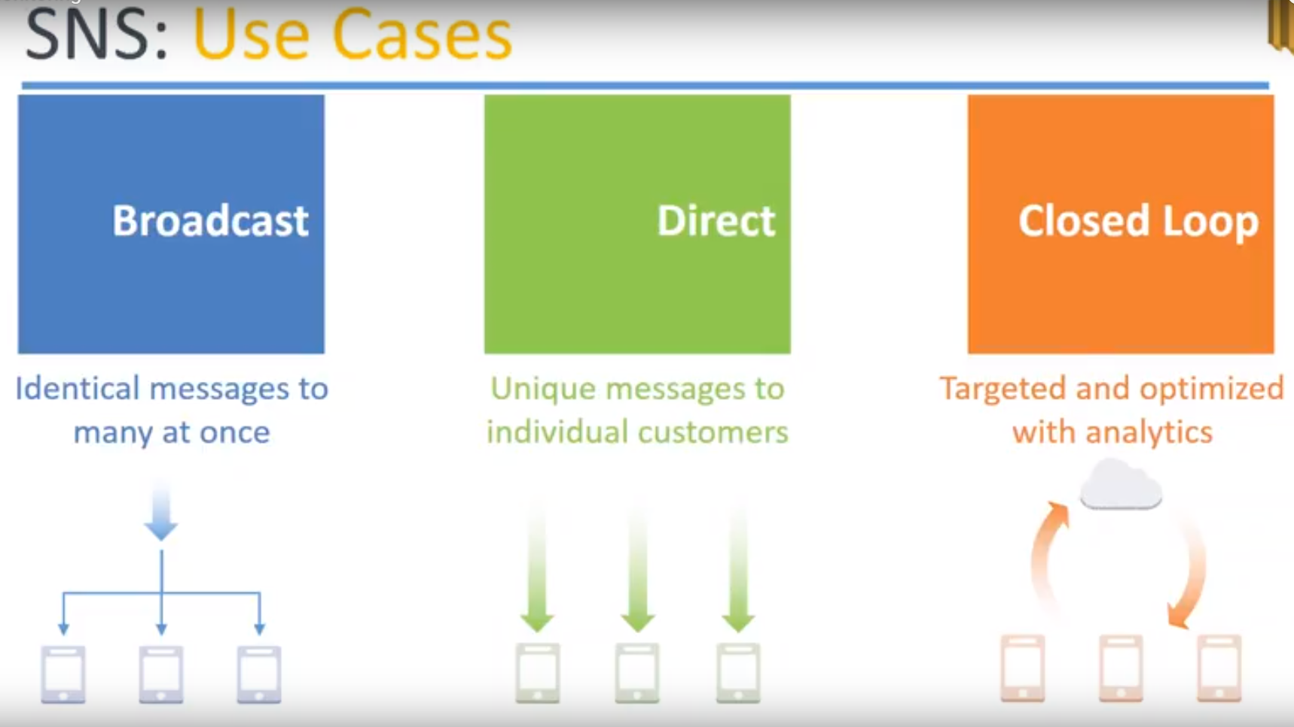

1. One common use case is **broadcast messages**: like a common holiday packages sent to a lot of people that is identical messages to many people at the same time.
2. then there is a **customized** (Direct) **messages** If you have used uber or some kind of a ride-sharing service they know who you are and they know your usage patterns then there will be very customized to offer or a coupon for that sent only to you if you even try to put in the coupon code in somebody else more app or their account it won't work.

So you can send those kind of directed messages to only a very few people so those would cases also you can do with SNS.

1. **Closed loop**:

A certain group of people from a larger population will be taken for a targeted analytics that is in this case there will be a **premium group in the shopping categories.**

**Ex:** Let’s say Amazon Prime customers they will get a separate notification whereas the non prime customers won't get that notification.

**demo**

* how to create your own SNS topic.
* subscribe it and
* send email notifications

**CloudWatch** This is monitoring service provided by Amazon and

It can do monitoring based on metrics CPU networks or state monitoring or event monitoring that is whenever the state of a server changes from stop to running terminated, then you can get an alarm.

This is called as metric based monitoring or alert monitoring and event level monitoring also.

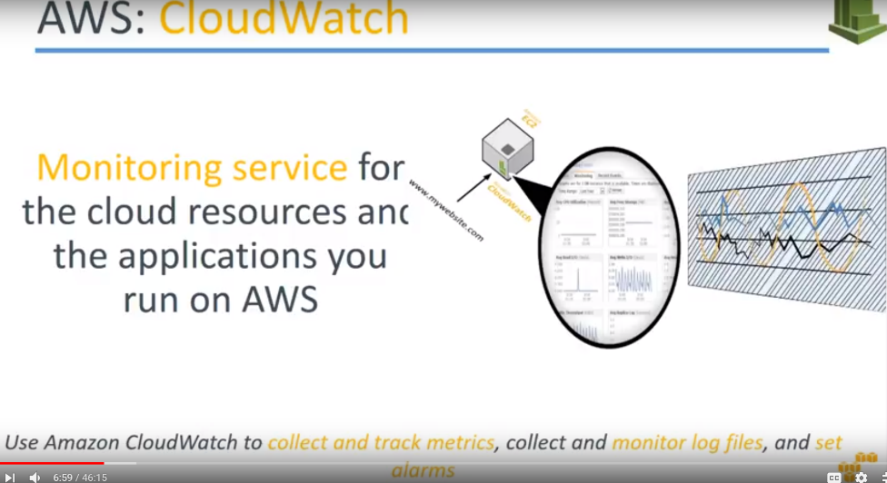

Cloud watch is a monitoring service and it can monitor both your resources as well as applications for you.

* When you want to monitor your applications then you go ahead and add your own custom metrics on top of it and feed it to CloudWatch. And
* You can collect all this log files store it and process it into your log management system.

**Remember** almost all the logs that you generate in Amazon can quite easily be sent to an s3 bucket and from an s3 bucket you can configure any other third party or Amazon's own logging mechanism that is graphing mechanism and visualize those charts.

**CloudWatch Architecture**

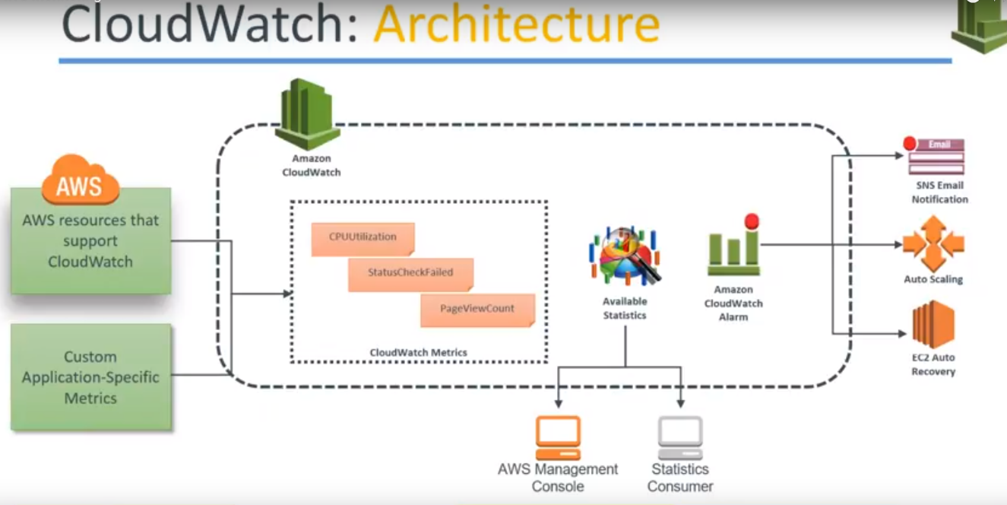

1.) let us say there is an Amazon account and there is a cloud watch configured already.

2.) There is a group of resources or group of metrics that are supported by Amazon, like CPU and networks latency, utilization what is many CPU credit balanced, whether my Hardware Health checks fine or my software, instance status checks, system status checks.

**If you notice carefully there will be a metric that will be missing there Amazon doesn't give you the memory metric in the monitoring aspect** **so you need to install some tools or scripts to measure the memory of your server or your application itself** so that possibility is there but by default Amazon does not give you the functionality.

3.) Metrics: Let us say in this case,

1. amazon resources are giving you CPU utilization and status check failed.. and
2. you want to measure the metric or some custom application thing then you have to go ahead and write your own custom application metrics and feed it into Amazon.

Example: there's a page view count how many pages are within my application.

4.) Available Statistics:

All these metrics are taken... So from the logs you get the metrics now.. From this matrix you feed it into the dashboard and the dashboard you can see it from your AWS console or you can have your customized statistics or logging or the visualization platform.

5.)And from here you can trigger alerts now see whether the threshold has been met when a CPU is 80 percentage Or my page view count is going by 1 million pages by every day.,whether it is increasing or decreasing based on that I will trigger a Alarm.

6.)when I configure in Alarm, I will push it to 3 different mechanisms :

1. I can send an email through SNS or
2. I can trigger an auto scaling so that that server can come up or come offline or
3. if the is an individual server configured for auto recovery then go I will go ahead and reboot the server

So all these actions are possible…

**flow is something like this:**

1. collect the logs..
2. from the logs I will identify the necessary metrics and
3. if the metrics are meeting or not meeting certain thresholds ,I would create an alert and
4. based on that alert I would take some actions.

**CloudWatch alarm actions**

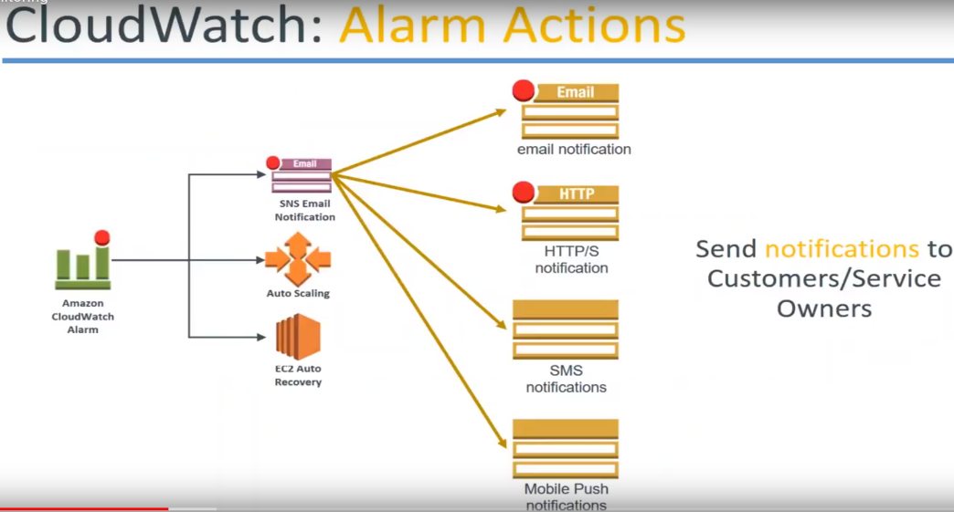

1. Whenever we are talking about **SNS** you have all this notification mechanisms available for you ..

Email, HTTP, SMS push .

1. **auto scaling**

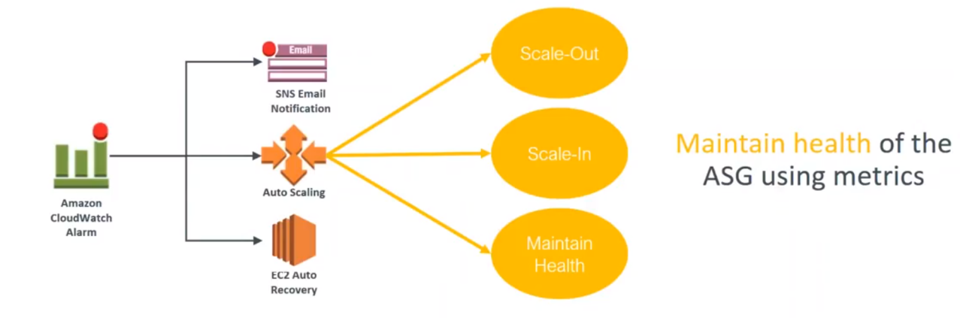

You can take any of these three actions… You can scale out.. adding more servers scale and remove some of them or maintain the health everything .. or if there is an unhealthy instance just replace that unhealthy instance.. scaling in scale out ..just maintain or replace that instance.

**auto recovery** the option is a default option provided by Amazon.. you just go ahead and choose whether you want to reboot the server when there is a server failure or whether you want to stop that instance or terminate that instance whenever a server failure happens.

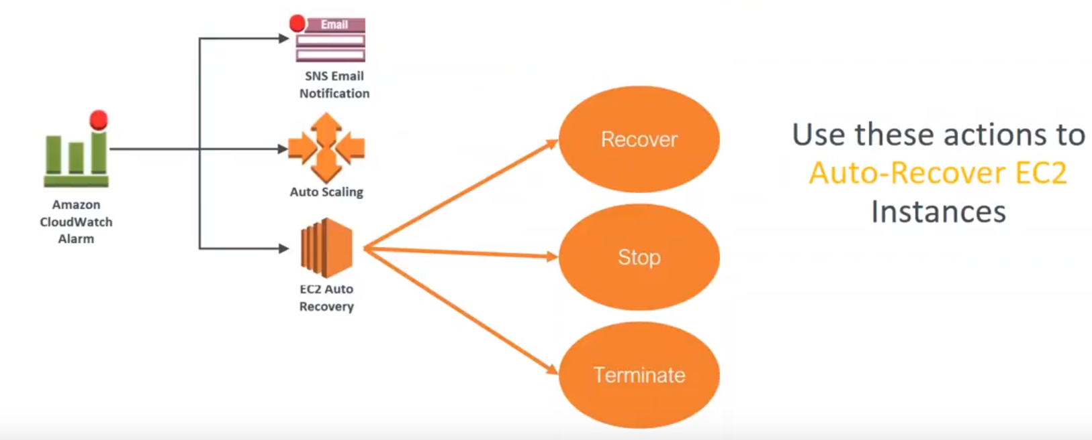

These three alarm actions are possible.

**CloudTrial:**

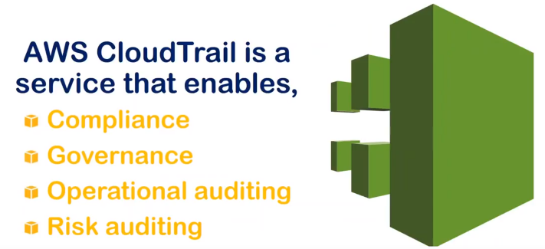

Auditing mechanism that is provided to you by Amazon when you have anything happening in your account that you want to have a compliant or governance necessity or an operational auditing necessity or the risk auditing …Cloud Trial can help you satisfy all these four types of requirements.

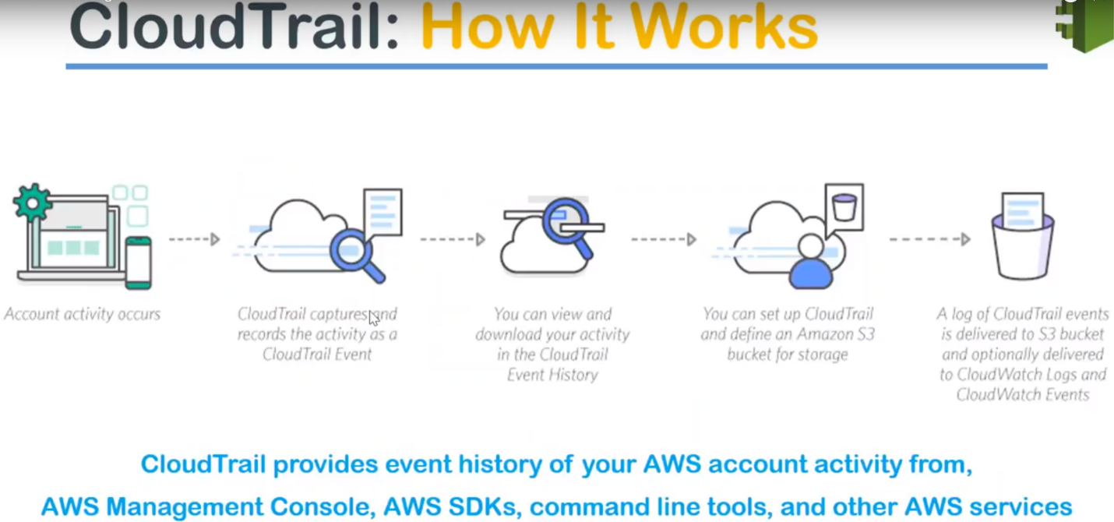

* Any activity that happens in your account whether you are accessing your account through a mobile or a GUI or CLI or programmatic …You will be interacting through API calls to your account.

All these API calls whether it is a read access or modification access it..

Modification means: creation of an ec2 instance or the modification can also be modifying the instance type of the Ec2.

* All of these changes will be recorded in your CloudTrial trail as API calls as events and all these events will be stored in your s3 bucket.
* Cloudtrail by default works from Virginia region only.

From Virginia, you can configure whether all the other regions can be monitored or not but you can go ahead and choose only to monitor a particular region.

But the logs will come and sit in your Virginia.. but if you go to CloudTrial, it will always say that it will be stored in Virginia.Now, we have identified what he wants to capture.

Then we are capturing it in a certain region. Once you are capturing it in a certain region, it is in s3 bucket then everything else makes simple because it's a log file now from all the events.

So from your log file then you can configure it is using cloud trail or cloud watch to generate events or you can use a third party logging mechanism to find out what events of your interest.

**For example:** If you want to get notified whenever there is a modification of a security group or if you want to get notified whenever the administrative password for an account is changed..

configure business rules by saying ..,if my account is going to be accessed every day from morning 9:00 a.m. to 10:00 p.m. and suddenly there is an access out of these hours I want to be notified.

You can pick up those events trigger a notification and you can corrective actions.

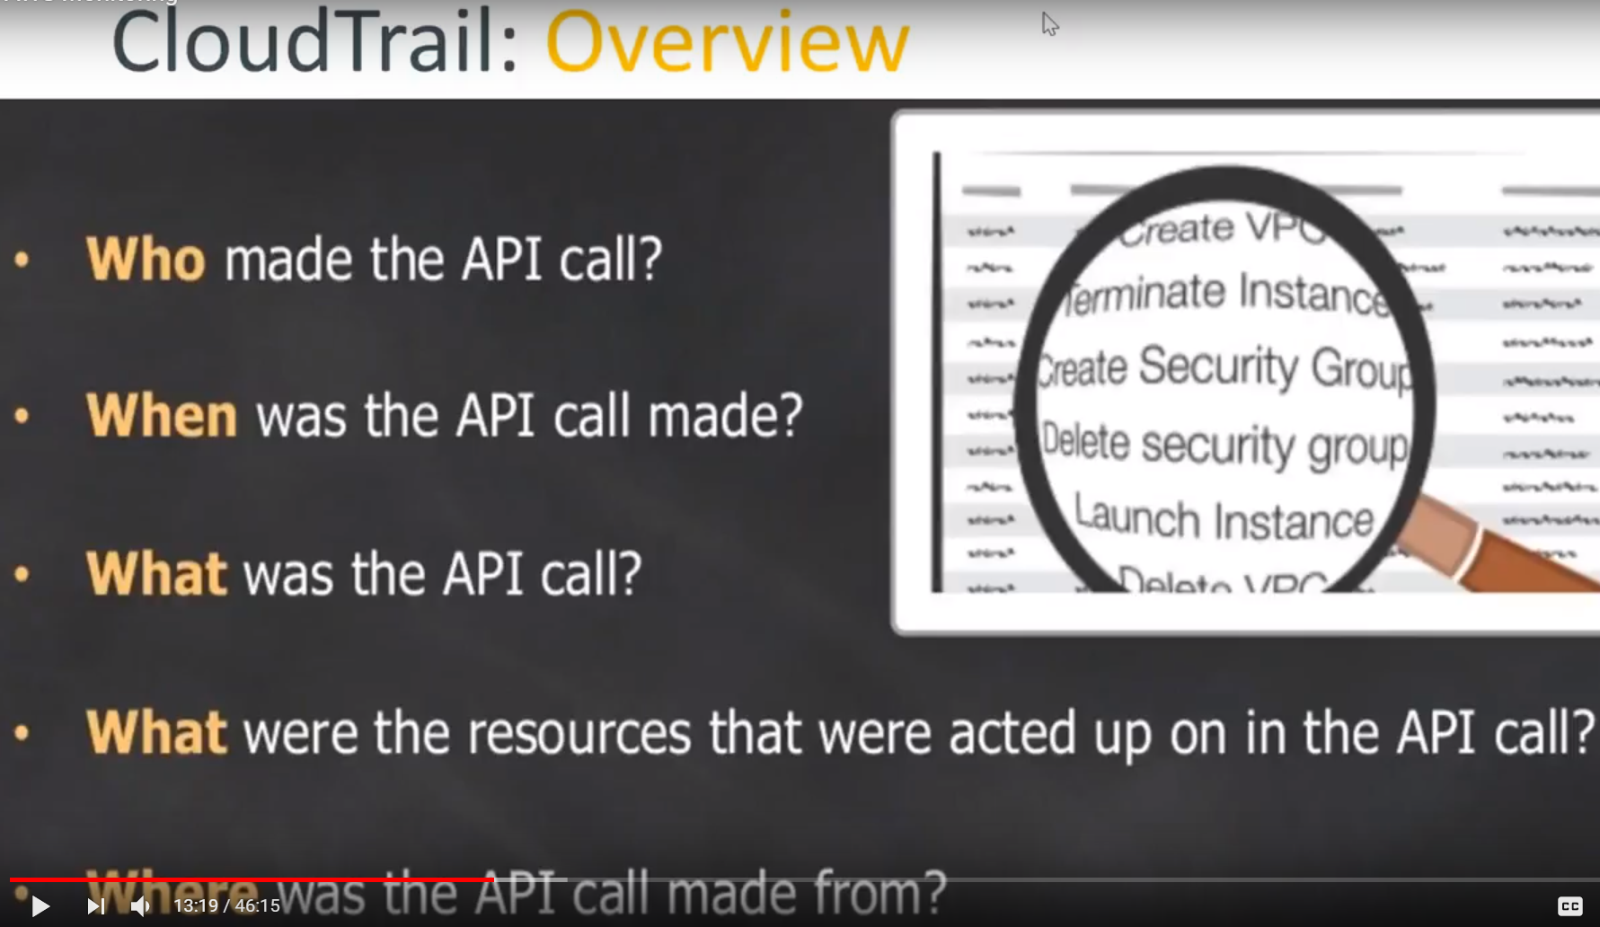

Typically, a cloud trail will log all these items.

* Who made that event.
* who created that API call and when the API call was made and
* what was inside that API call wheather modification or creation or deletion of an event and
* what resources were impacted by that API call and finally
* where is the IP address and timestamp and also the region also based on the IP address They'll have a region as well weather and it will also see whether from GUI you are coming in whether you are choosing the API from ap-south or virgina or any region also.

All these information will be there in your cloudTrial logs.

**CloudTrial Overview:**

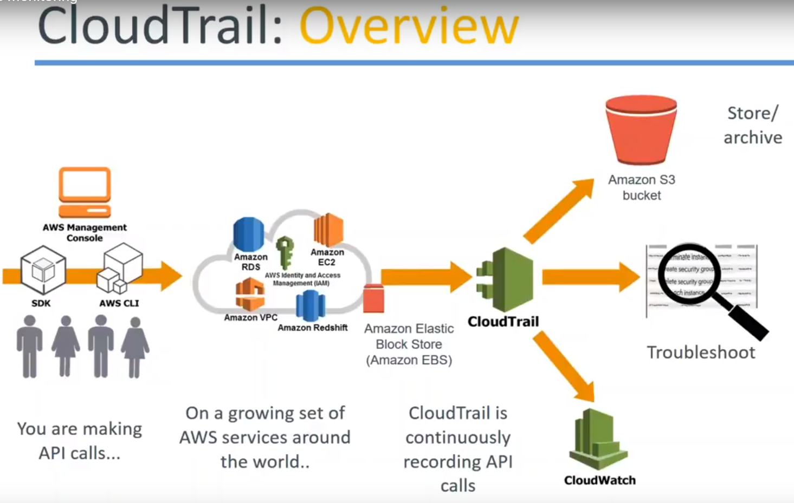

Flow is something like this…

1. On the left hand side you have people.., accessing your account through the GUI or SDK or CLI..All these three different mechanisms are possible.
2. Then they are accessing the cloud trail monitoring services and each of these services will be feeding in those events to your cloudTrial and
3. cloudTrial will be storing it in an s3 bucket.
4. it will be triggering events in your Cloudwatch if you configure it or
5. if you want to go ahead and do some real-time monitoring and troubleshooting..., all those things that is also possible.

**Use case**

How a monitoring alert is triggered.

let us say some person has gone ahead and created some accounts or deleted some accounts.

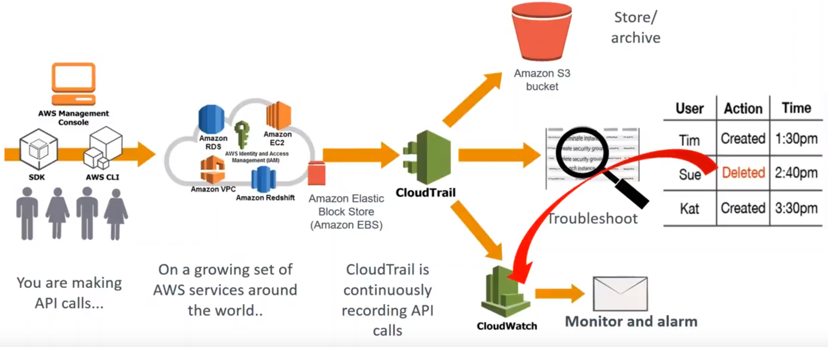

So automatically you are going to configure some notifications showing that whenever an account is deleted saying that event immediately or trigger an alarm in your Cloud watch and cloud watch can go ahead and create an action now... it can send an email or it can create a lambda function to revert it or anything is possible…...

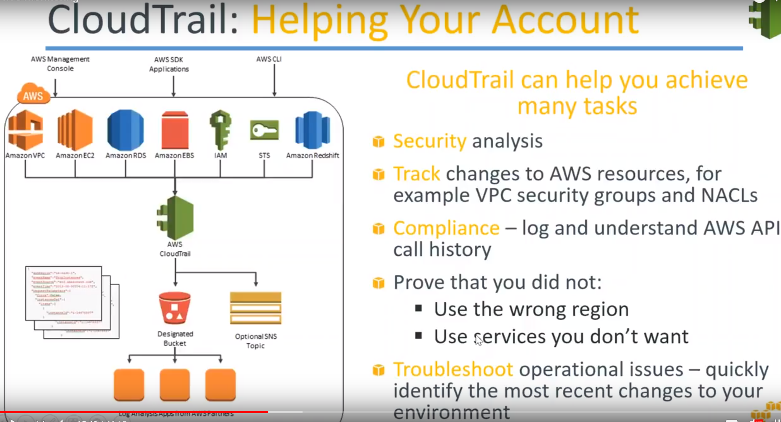

**In short that is Cloudtrail works… People trigger events Cloud trail monitors those events and if you are watching those events then cloud watch will trigger an alarm for you..**

In short the cloud really helps you to achieve a lot of compliance activities.

Some of them unlisted here..

1. For example security analysis
2. tracking the changes made and
3. if you want to provide your auditors what is the compliance log or what is modified and when then have those kind of logs and
4. you can also prove that you are not the wrong region and say GDP our or some kind of data production law is there then you can show and say that all my resources are in the US region or Europe region only and I am not using any other region.
5. In case there is a accidental deletion or modification of some resource you can go ahead quickly check it for watch and troubleshoot an operational issue also using the events.
6. There is analytics also you can use those logs to find out what is being modified more, which of the sources getting changed quite often ..Should we create a bigger resource or should be give more granular controls.., so that those modifications doesn't happen.

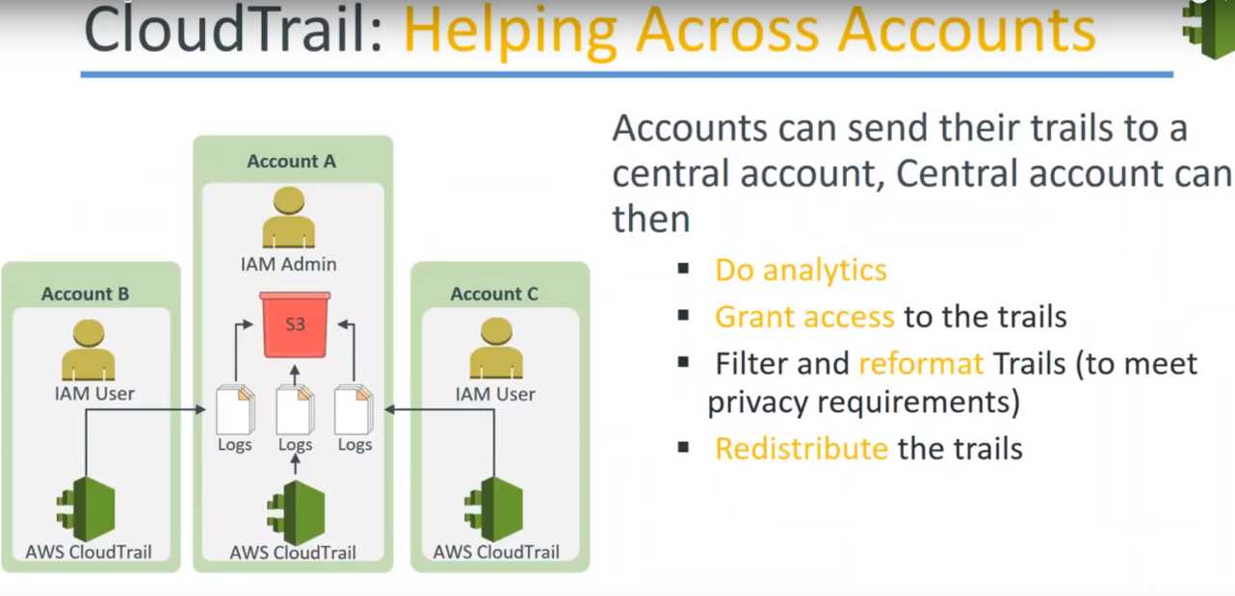

you can also redistribute the trail also. one of the Cloud trail configuration is shown below:

You have the master account A on the middle and if you can notice the cloud trial logs from the account B and C are being fed into the master account...

What this technically does is: If your account B and C gets compromised for some reason ..,the logs or the event of those logs will not be compromised because you will still have those logs files and still you will be able to trace back the steps and recover your events ..

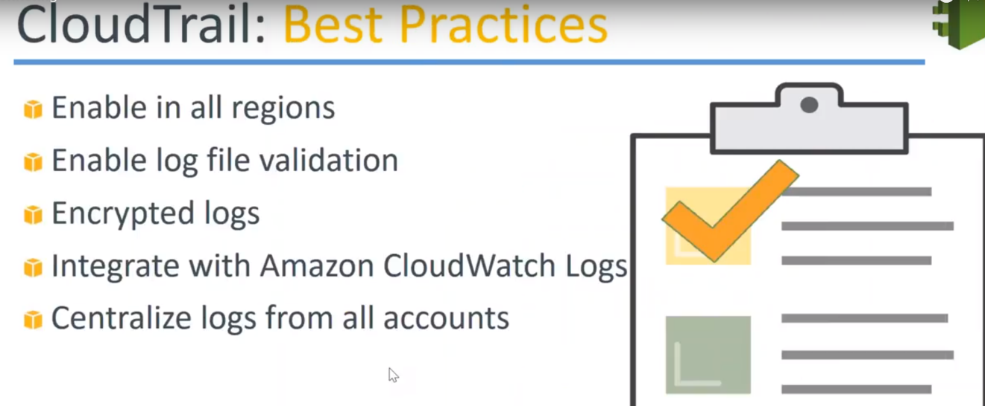

* Go ahead and configure cloud trail in all the regions because you will not know where your next compromising attack will come from you might be using the resources in Virginia but some attacker might try to get into your Oregon region or maybe Ireland region and you will not be able to notice that until it is too late so go ahead and configure that and
* for all the logs that is stored in s3 bucket go ahead and enable versioning so that if somebody is going to delete some versions you will still have the older files and you should be able to get some notification out of those versioning as well and
* Encrypt your log files it's all a checkbox that is provided when you're configuring cloud trail..**So if you want to be really secure go ahead and enable log validation through versioning and then you can go ahead and enable the encryption as well so if somebody copies a lot of files they will still not be able to understand them without your keys** and
* Centralize your logs from all accounts as I show in the previous screen. We have one master account or an administrative account where all the logs are coming in. So it is easier to administer and to compliance activities from centralized accounts.
* It is also possible to integrate Cloudwatch. So if you want to do it go ahead and do it I always go ahead and create some custom events for identifying whenever there is a resource modification in your accounts.

**SES(**simple email service)

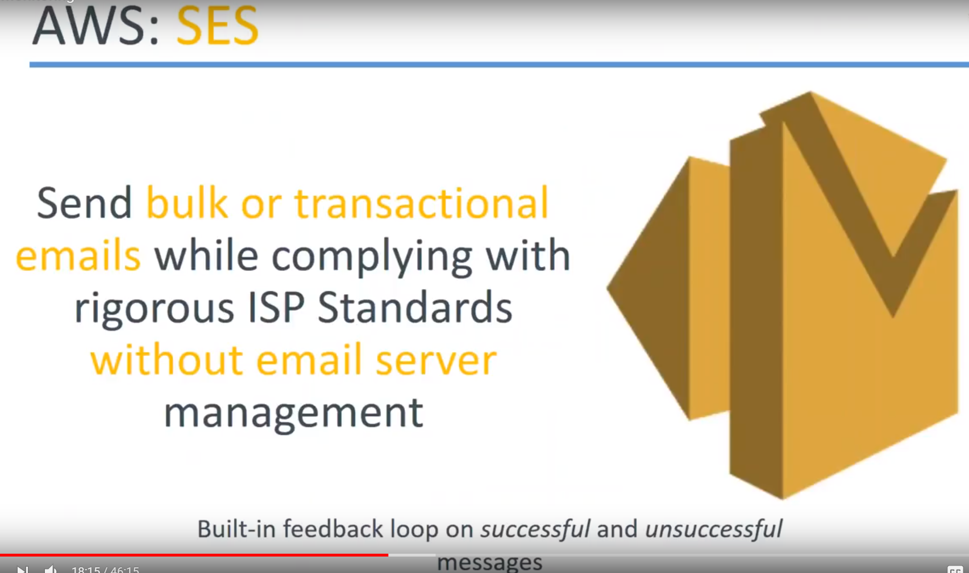

* quite interesting in my opinion ..,if you are a email promotion campaign manager. Then you want to send the millions of emails from your mailbox. It is not possible whether you are trying to use a gmail personal account or if you are using any other personal a/c.. because once you reach a certain threshold you will be triggering some filters and automatically your account will be temporarily suspended or permanently banned.
* So, for sending mass promotional emails, you cannot use your personalized account you need to purchase a professional paid account for those services and Amazon services is called as a simple email service.

Amazonas tied up with a lot of ISPs and they comply with the ISP standards because if one IP address is consistently sending millions of messages quite often..

ISPs ban those IP addresses so that they don't receive those more messages and that their SMTP servers are not overloaded..

* But in this case Amazon has tied up with ISPs ..,so what happens is: Any message coming from a SES service there is a guarantee of that message reaching the inbox of your subscriber and not the spam box or the jump box.
* These are the advantages of getting using SES, and once again it scales automatically whether you send the **messages to one person or ten percents or 1 billion people the messages are delivered and the services is also scaled and you get a failure notification for each of those messages also you can configure what is successful what is unsuccessful and you can read trigger the unsuccessful messages also.**
* **One caveat** is just not that, you have a target email addresses that you can start firing. That won't work. Each of those target email addresses have to subscribe to you.. That is., they have to pre-approve so that they are ok to receive messages from SES. **In other words it's like a subscription service only and once your email addresses is approved then you can go ahead and send messages to all those email addresses**

**Demo**

We are starting with SES, SNS then we'll go to cloud watch and you set up a cloud trail at the end of it.

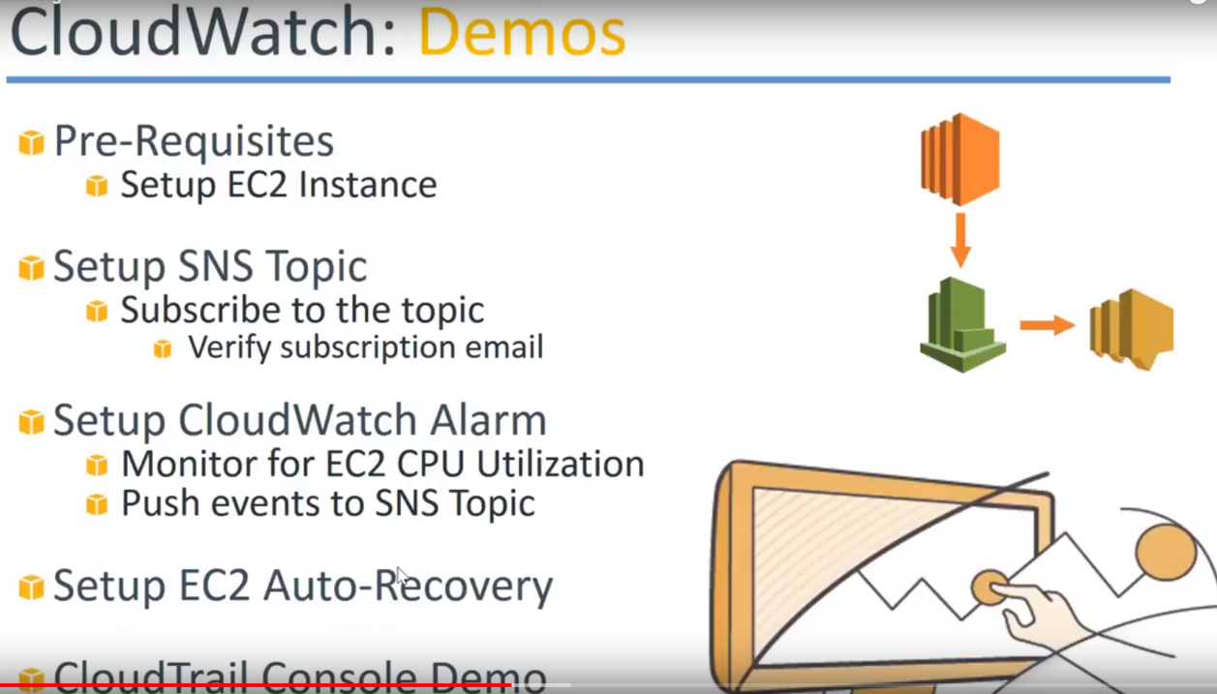

1.)**SES(Simple Email Service):**

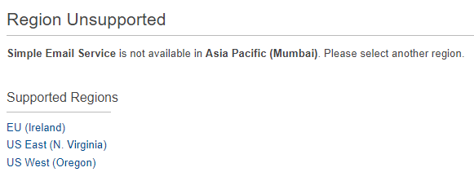

a.)I have chosen the Virginia region because it is not available in all the regions. It's available as of now only in three regions.

b.)If you have a particular domain name say mywebsite.com and you want to send bulk emails from that domain name then you have to verify that you own the domain name.

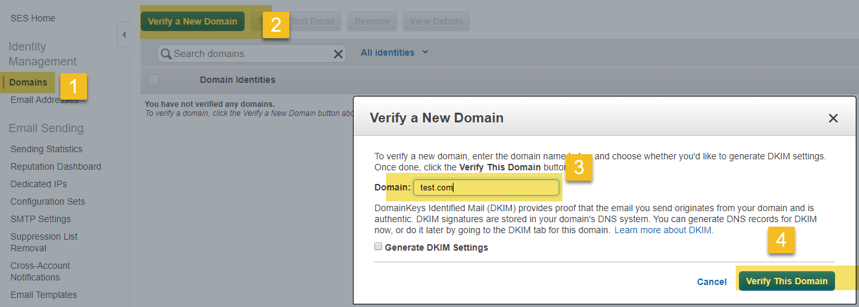

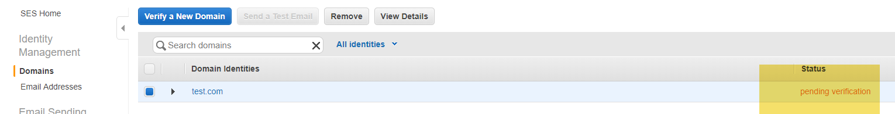

Add the domain name here… it will send an email to the administrator of that domain name and it'll send some verification code and then you have to go ahead and do that.

Then your domain key identification settings will be done because these are all the things that an Internet service providers Amazon does so that people don't use the service for spamming purposes.

c.)I don't have a domain name but I can still send email addresses because I have approved of one particular email address of mine from which we can send email addresses.

So you can see there is one email address already.

I am going to verify another email address that I have given here..

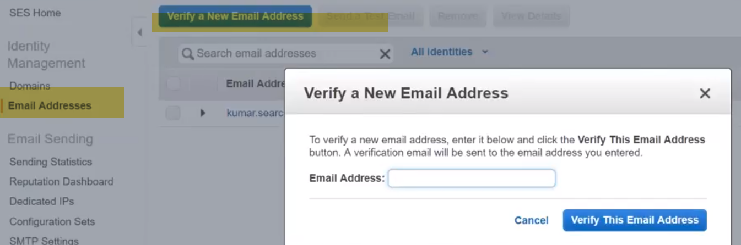

d.)Other interesting thing about SES is Quotas and max rate.

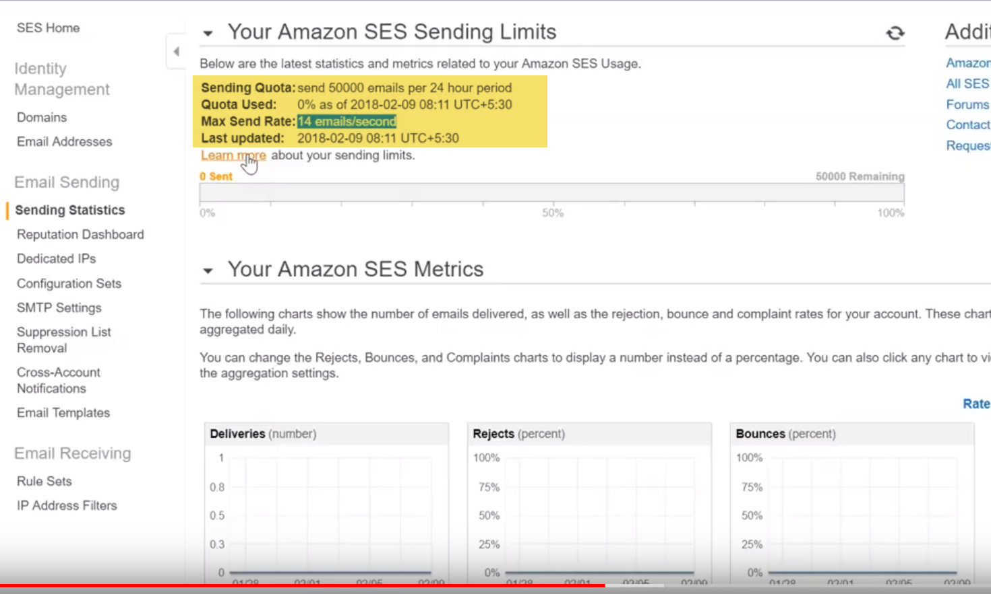

Your quota is something like 50 thousand emails per 24 hour period.You can of course go ahead and raise the support requester by explaining your business case and Amazon is convinced they will increase this quota to a higher limit and

As of now I can send only 14 emails per second.So if I multiply it 86,400 I can send about close to about 2 lakh emails/day. So that is the max I can send I cannot send millions of emails every day …

To increase your limits and of course you need to justify damage on saying that you are using it for legitimate purposes and not for spamming or any other unauthorized or unethical use..

**SNS**:

1.)The first thing we need to do in SNS service is: create topic.

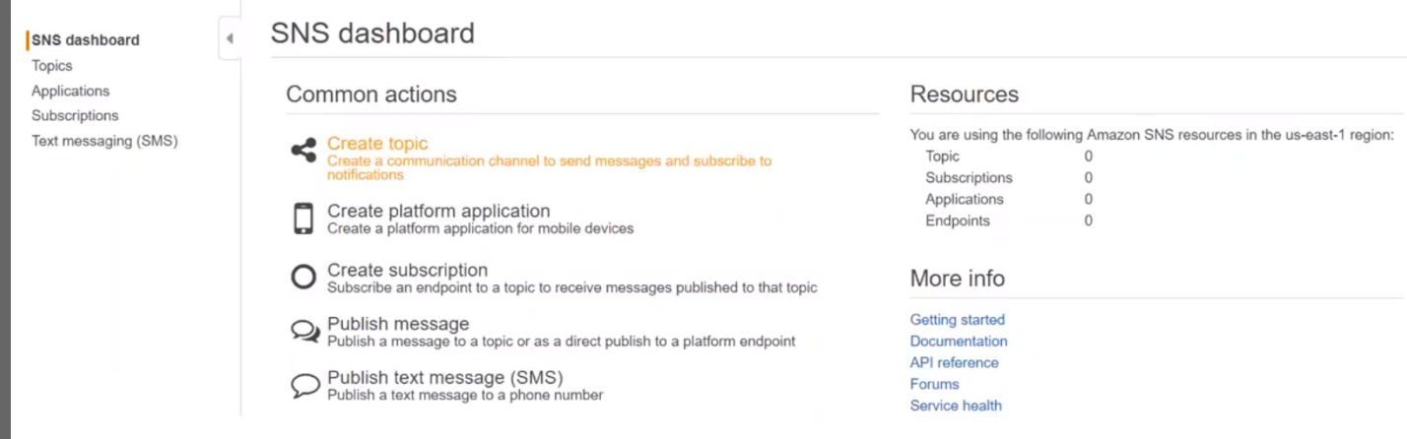

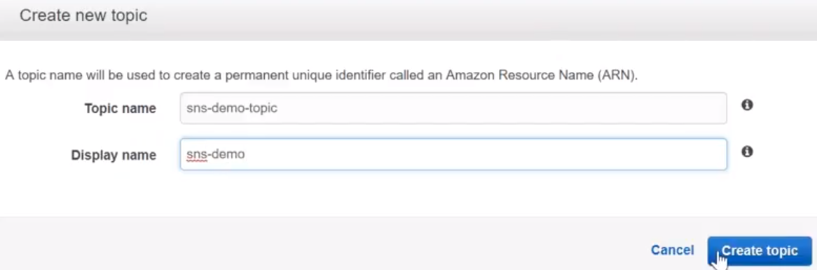

2.) Topics are identified by their names.

So display names has to be 10 characters and they are uniquely identified. You can see, there is NO subscriptions in the bottom of the page.

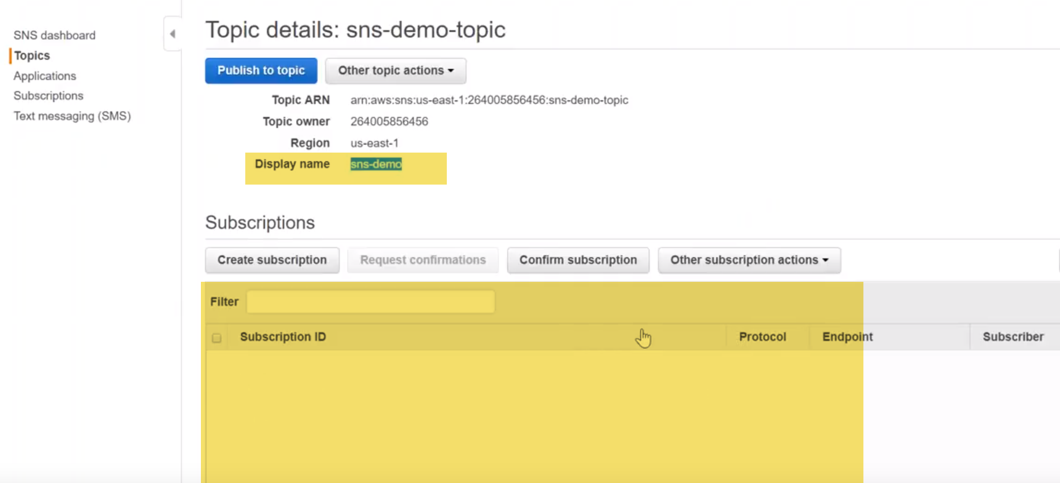

3.)I can create my subscription by using this icon on the left hand side.., but if you do that you need to copy this ARN number also.

You should be getting a notification email to subscribe but let me also show that because I have done it is my email address as well…

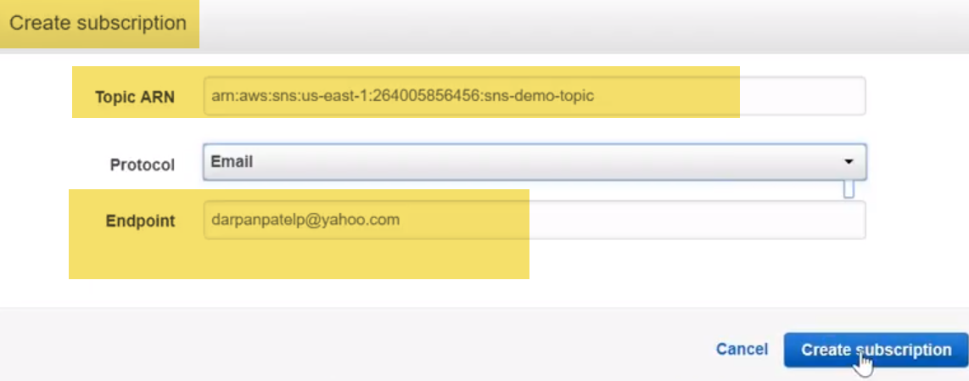

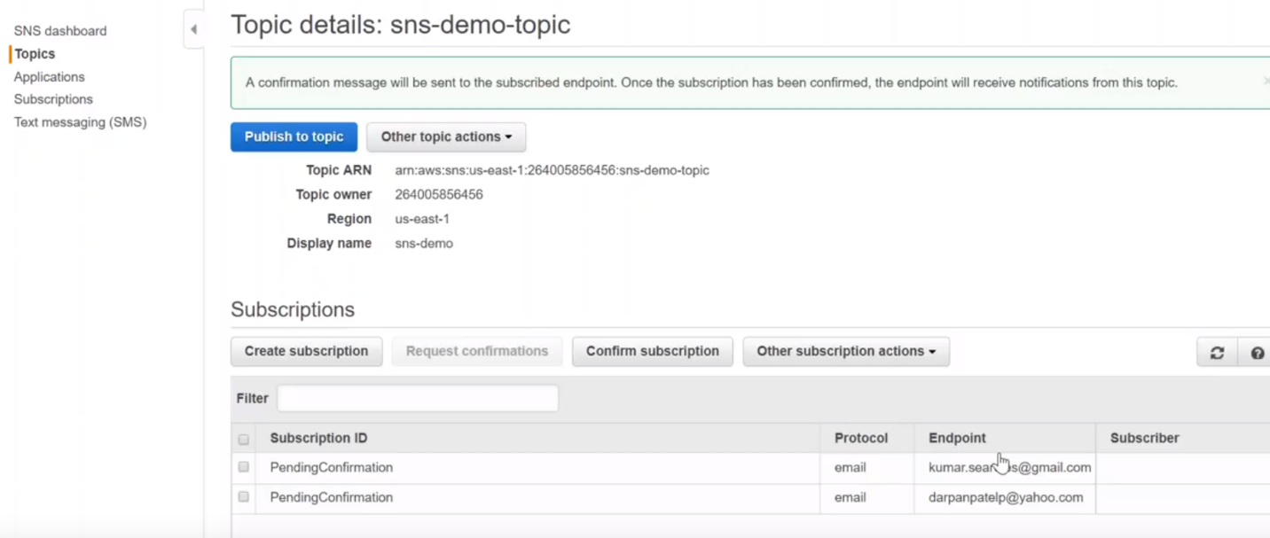

4.)let us go to our email box now.. So we have couple of subscriptions here

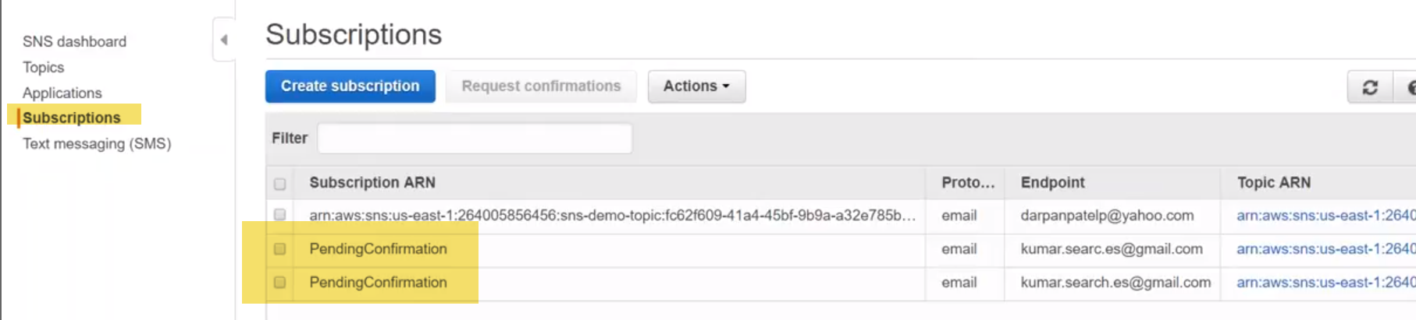

check my email address now is it you can see here there is an SNS demo notification..

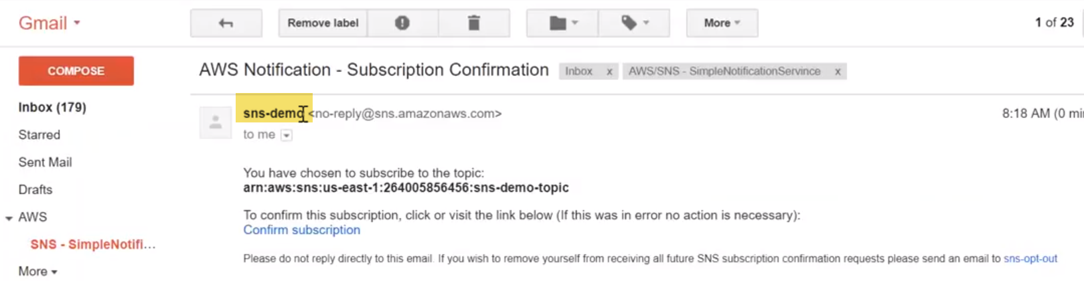

**SNS demo**: 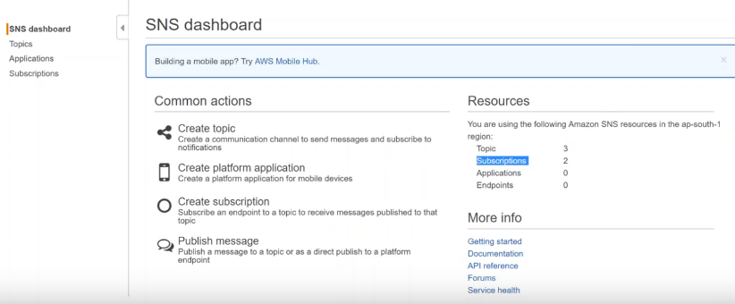

I have already 3 topics and there are 2 subscriptions to those topics configured…

First thing that you want to do is: create a topic then you need to create a subscription for that topic.

1.) click on create new topic

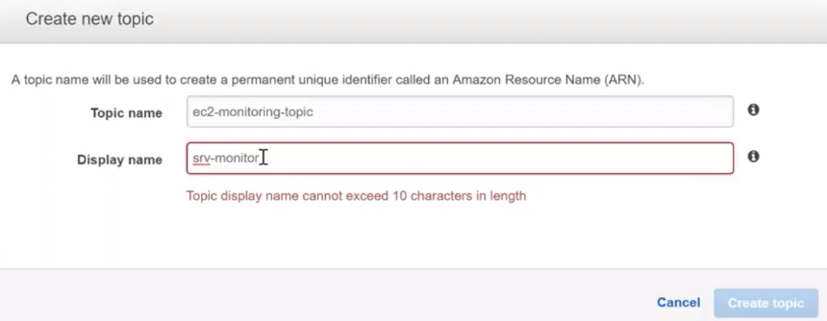

2.)We can do all these options.

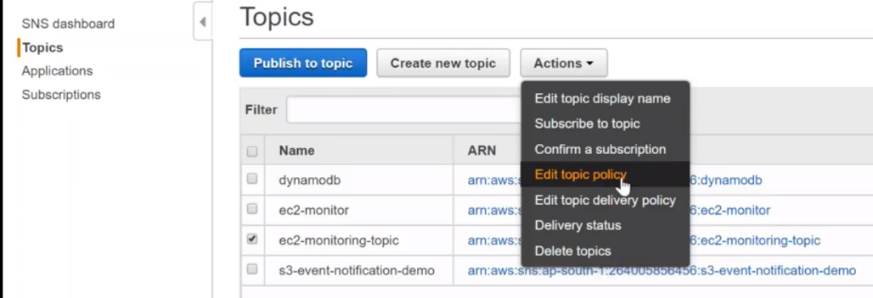

With edit your topic policy -🡪where all I want to deliver my outputs to..

So here if you can see allow the users to subscribe to this topic …Only me… I'm going to say everyone can subscribe to this topic.

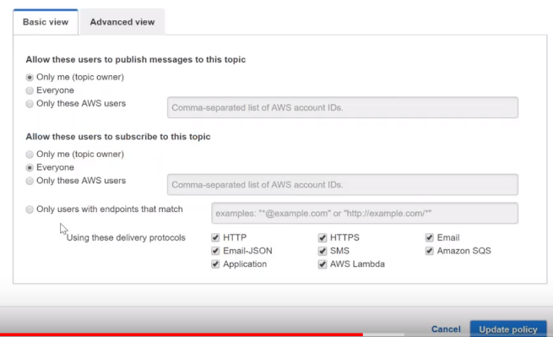

Only one who is going to be able to publish the list …whereas a subscriber can be anybody could be everyone or anybody which is an endpoint that matches this URLs

3.) create a subscription here

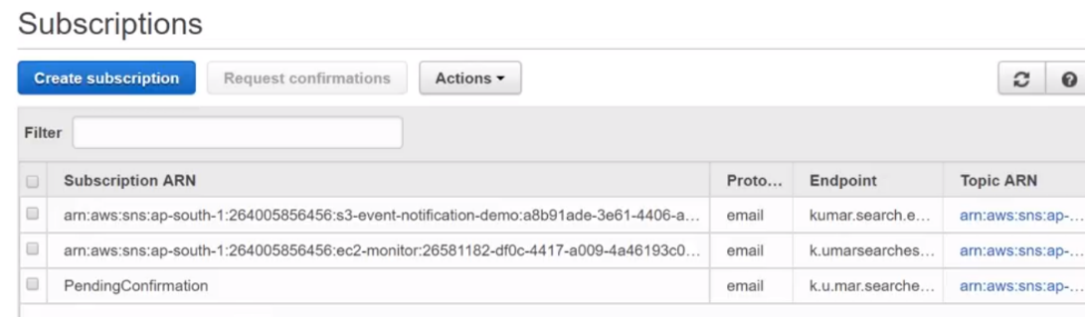 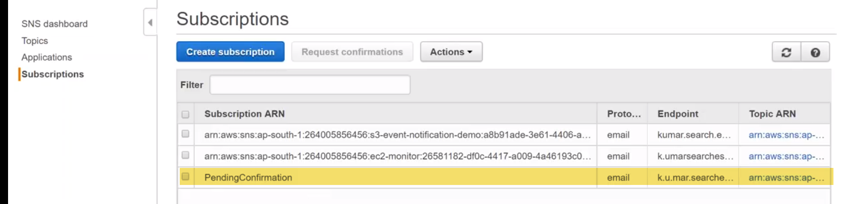

Let’s start a server and then create a notification to this alarm …

For services like s3 which require additional permissions to be attached… then only when you attach those policies we will be able to get those notifications.

Go to my s3 bucket-🡪 Bucket🡪properties.

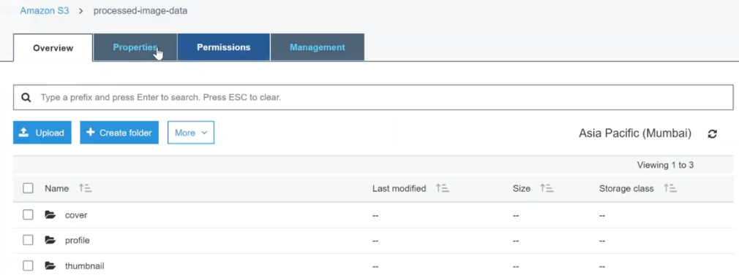

Events🡪 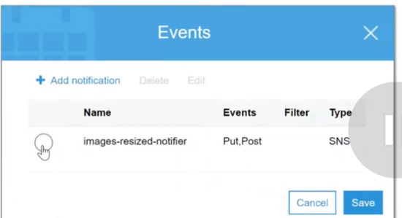

Edit-🡪 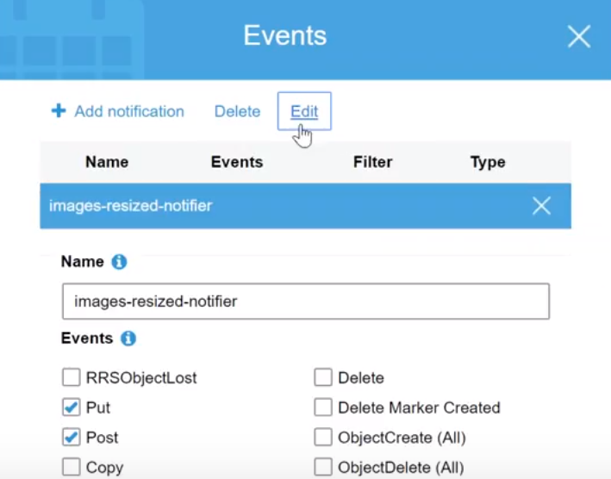 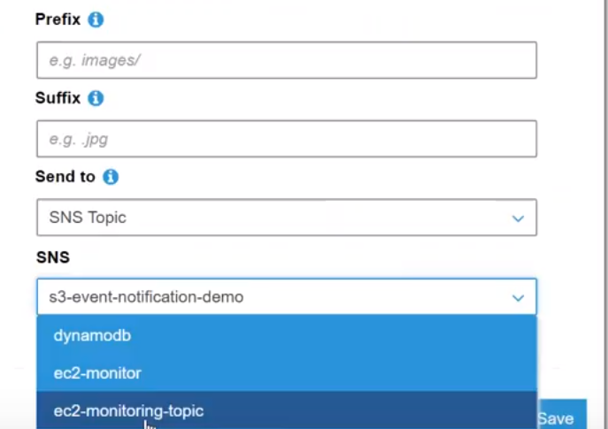

Select topic which I created….

Once I add the policy then S3 notification will start sending SNS and SLS will in turn forward it to my email address. That is S3 configuration of SNS…

Let us go ahead and do it for ec2…

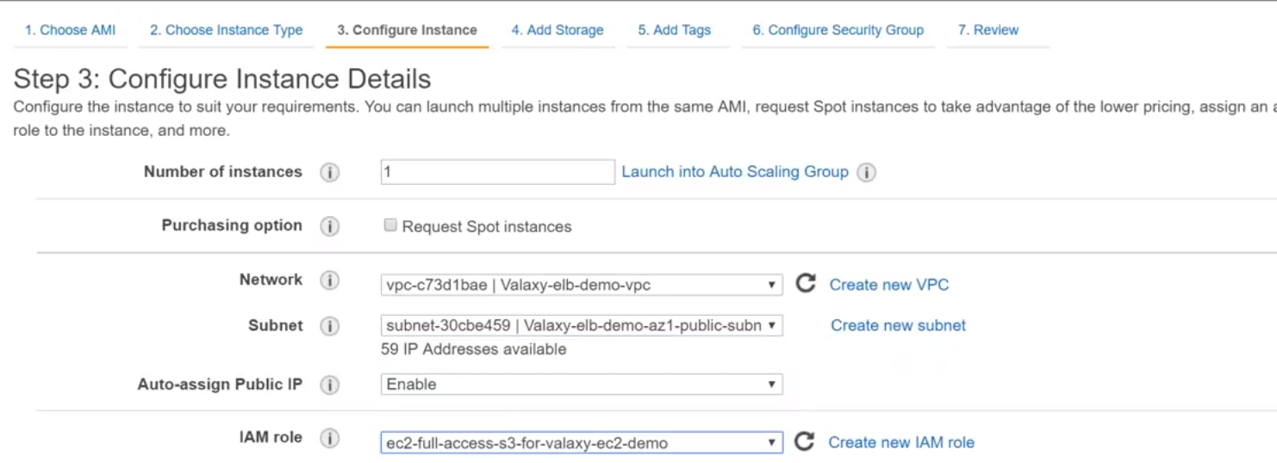

Goto monitoring -🡪you can see here there are no alarms that is configured right now. The easiest way is to just go ahead and click and create alarm.

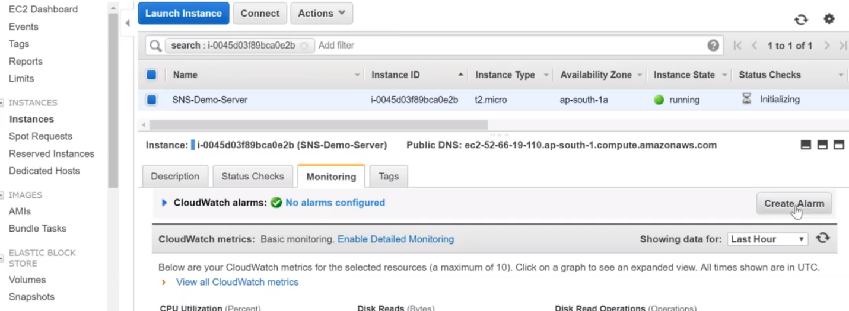

send a notification to-🡪 it is asking me where I want to send a notification.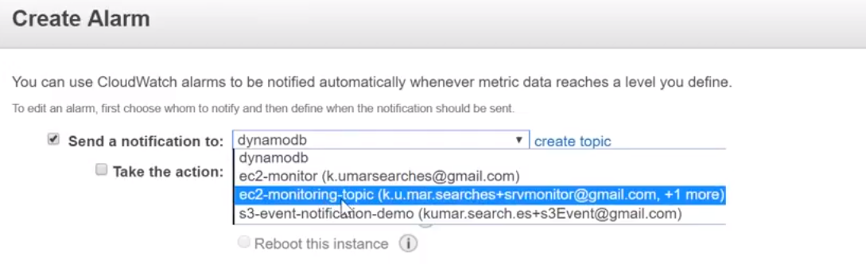

Take an action: a.)recover option-🡪 if it is C4/M4 Or certain group of instances …there are options to recover server, when it goes offline.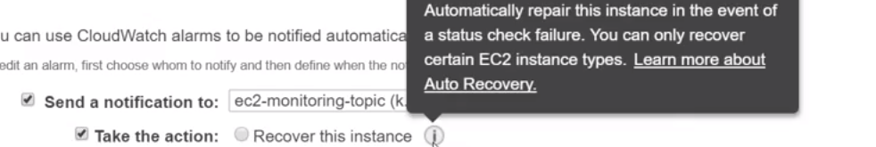

b.)For terminate/reboot instance, we need to create IAM role…

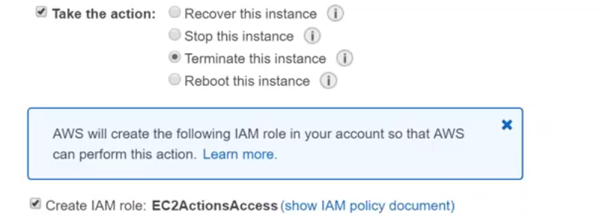

C.) Status check failed for any instance---reboot instance…

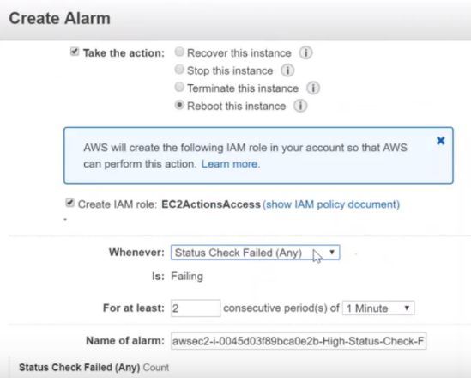

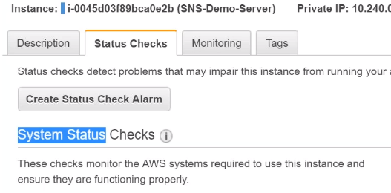If system unavailable …then we get alarm

If any status check failed consecutively twice for period 1 min.. it will trigger alarm

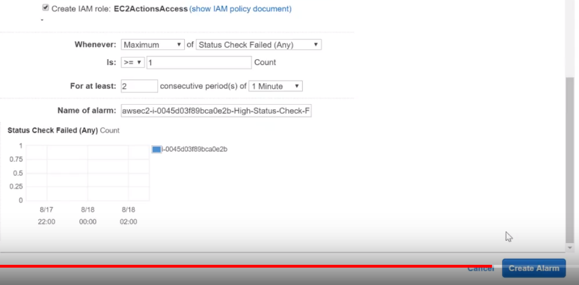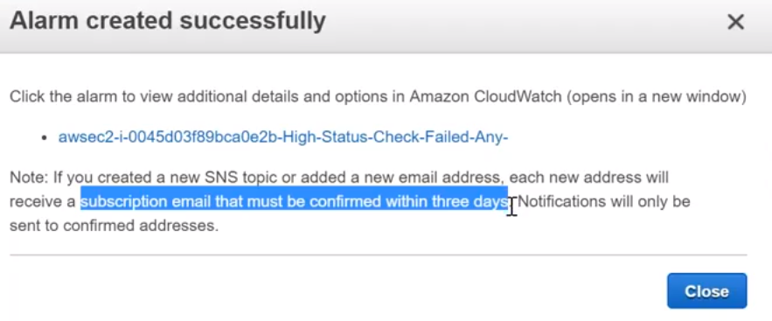

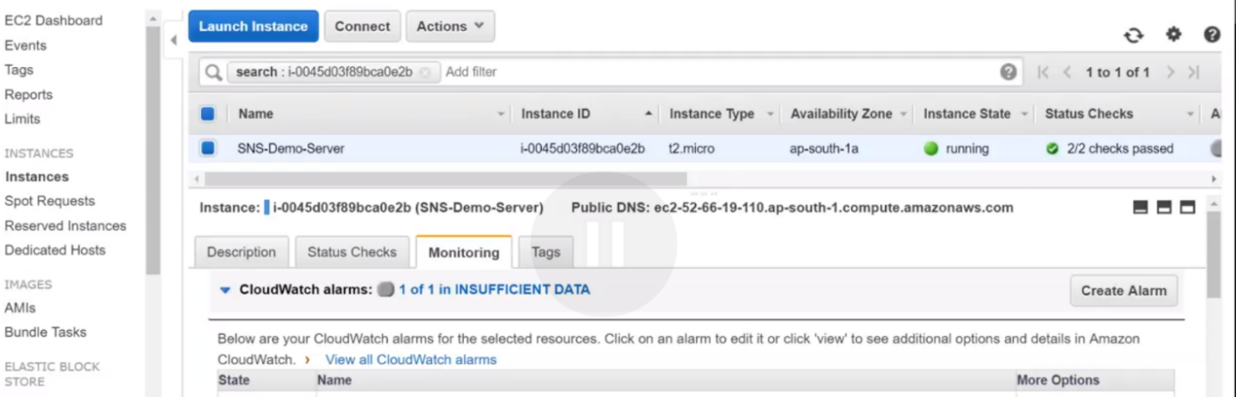

Before it used to say No alrams configured. Now show insufficient data..

Open **Cloudwatch** 🡪 used for doing the VPC flow logs it is the same

**Alarm:** there are three states for an alarm :

**alarmed state** that means an alarm has been triggered or insufficient data or okay. 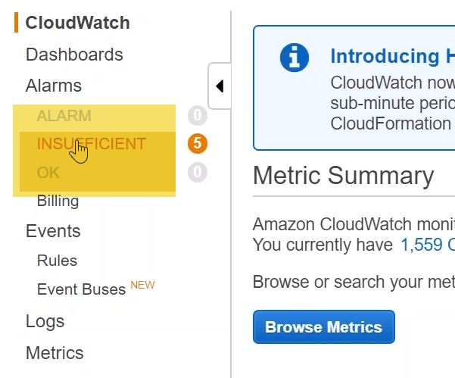

when it says insufficient data .It does not have enough information to make that call.

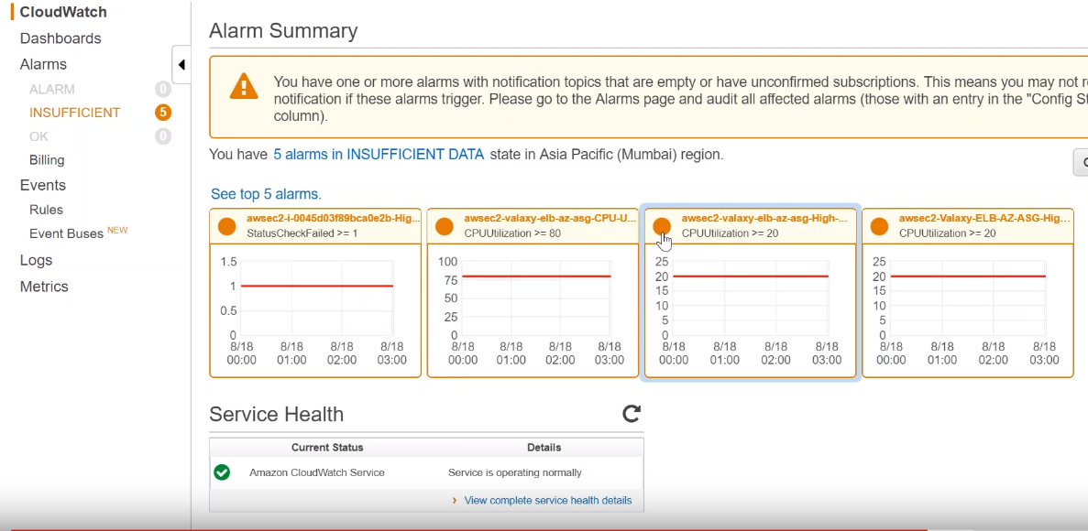

you can see here the various alarms

this is for auto-scaling that we configured ..alll 3.

This is just now created where status failed is greater than 1 so it is collecting the data as of now and it says that it has insufficient data to make a decision whether it is an alarm status or OK status.

I have seen exam questions on this what are the alarm different alarm status.

**Note:** by default that you will not have detailed monitoring… that is a one-second one-minute monitoring you need to in a detail the monitoring in your account.

On ec2 dashboard -🡪it says that a Cloudwatch monitoring is basic when you're setting an instance there will be an option to say enable detail the monitoring for that instance.

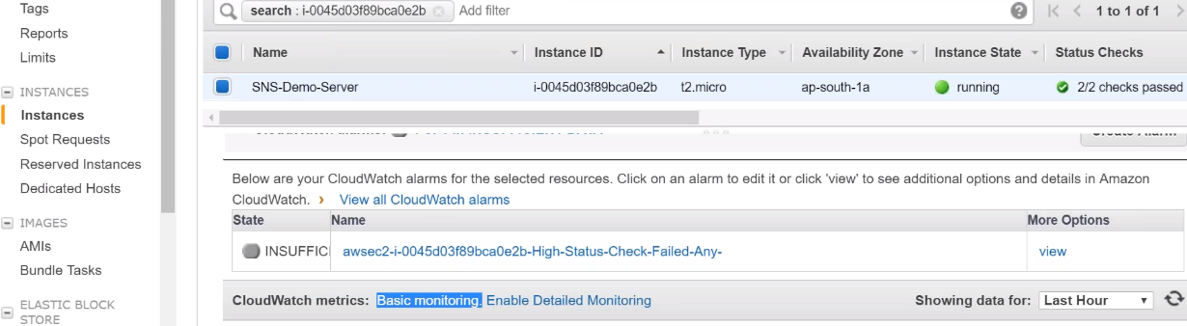

On Ec2 launch-🡪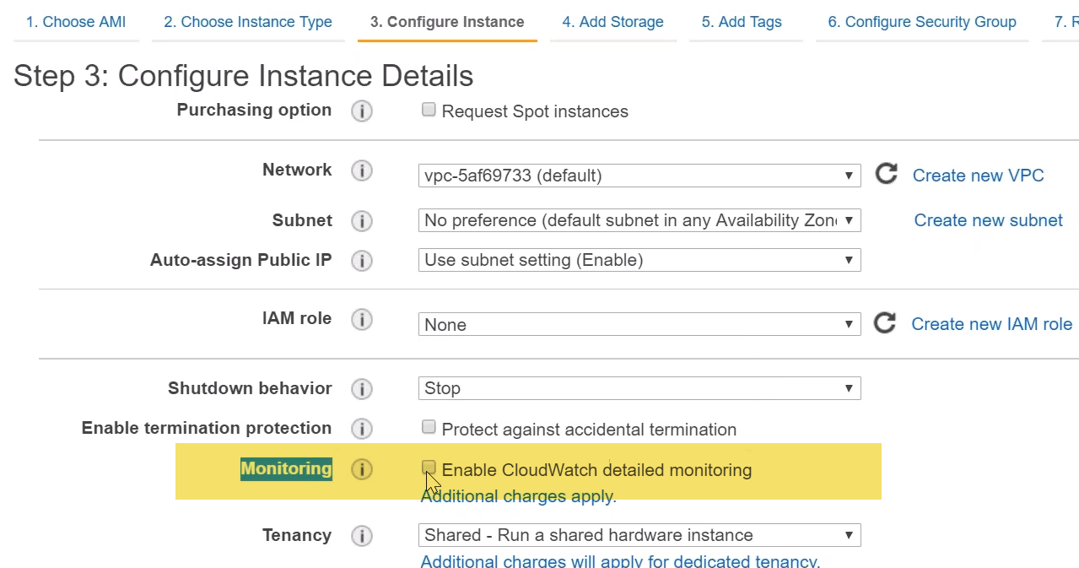

by default this is not enabled.

when you go to RDS or some other service you will see that also….

-🡪we still have insufficient data it is going to get take some time I guess for the data to completely register here.

let me go ahead and create another alarm… We are now doing from alarms dashboard now.

click on create alarms 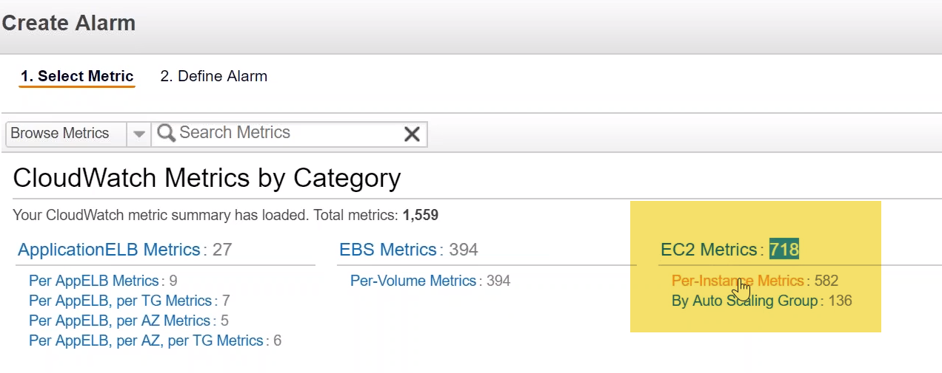

**you need to pick up exactly which metric you want to measure and then based on that you need to trigger an alarm here.**

We are having an ec2 instance and in ec2 that are close to 718 metrics…

We are going to choose a per instance metric because we are having only one instance we don't have an auto scaling group… Click on per instance metric… and it is giving me a big list of options..

find out the status change there will be a status change matrix here we just want to choose that one you can see here

The first alarm that we set is successful that is there is no problems with the CPU or anything and it has **been consecutively taking for every 2** minutes and it is getting successful message.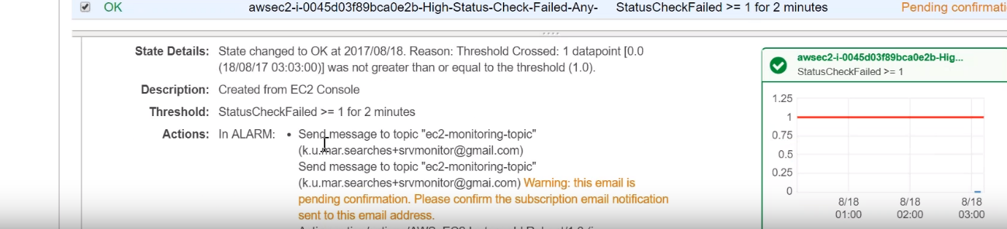

you can see this is the status message… that we set up for this alarm and it has reached the ok state that means all the parameters are good and there is no problems with those parameters.

Two things ….I wanted to show is one is creating a topic and subscription on SNS

2.) setting up alarms in your Cloudwatch and attaching those alarms to your SNS topics.. so that emails will be triggered to whoever subscribe to those topics .

Those are the two things I wanted to show.

We already saw how to do this in S3 that is whenever a bucket is added or modified deleted we'll get a notification.

Today we are seeing how to add notifications to our alarms whenever as server changes state…

-🡪you can create a line chart for example for your ec2 instance..

Clodwatch dashboard-🡪 Add widget-🡪Line chart-🡪 Ec2 instance🡪 Per-instance metrics🡪Select metrics

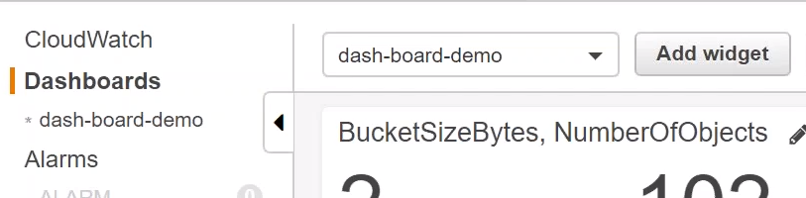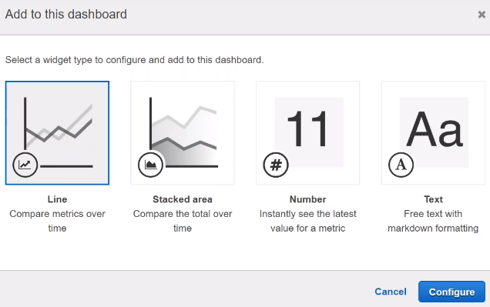

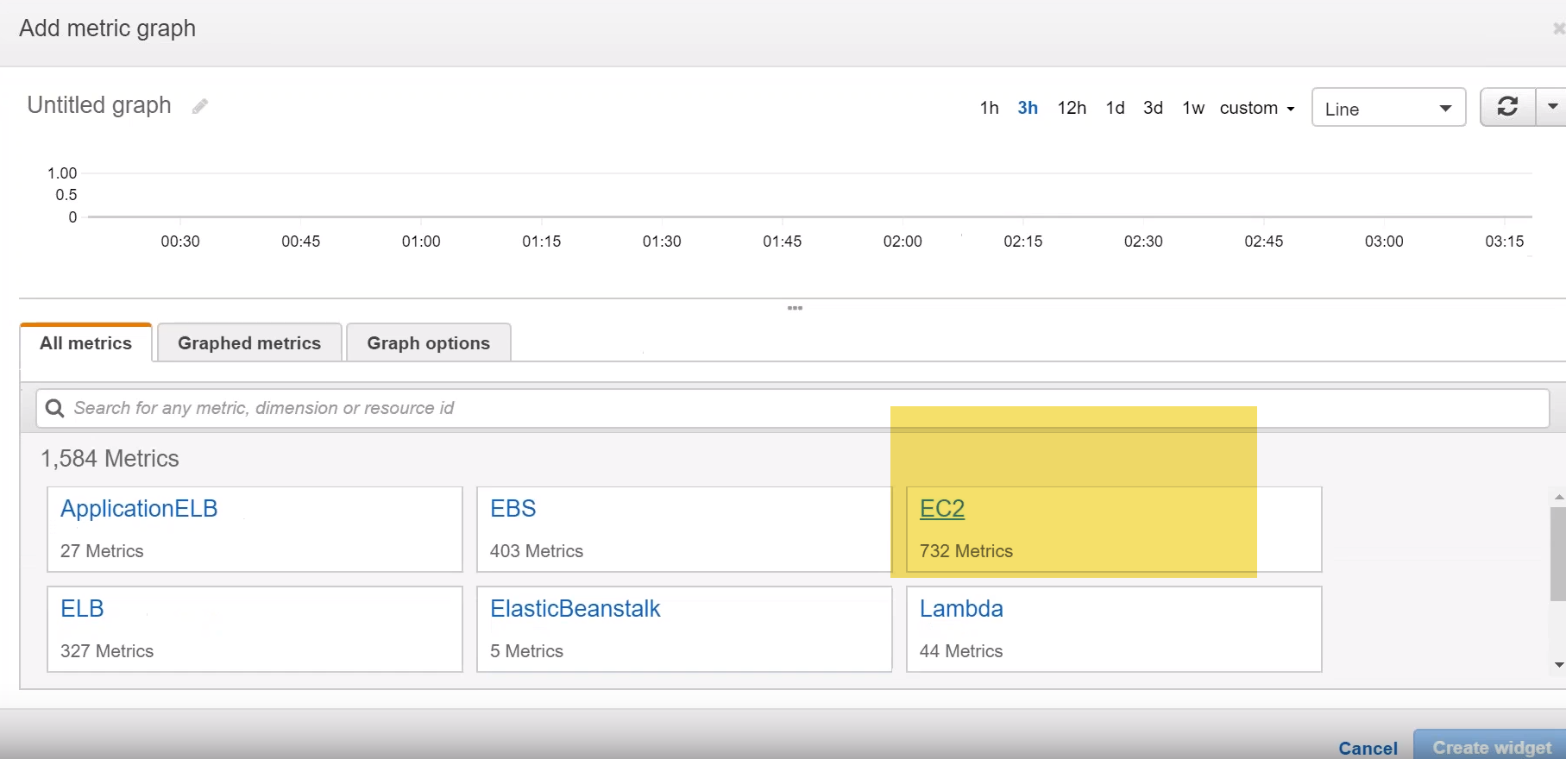

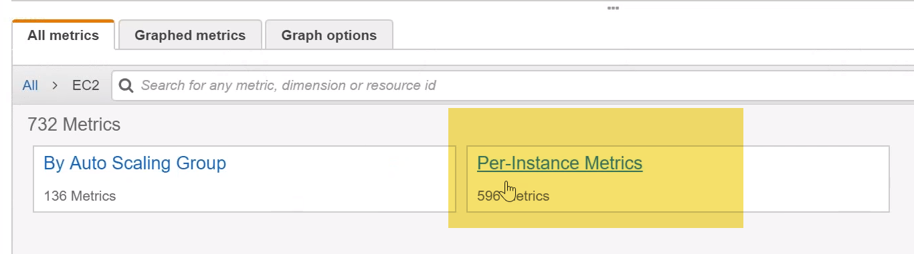

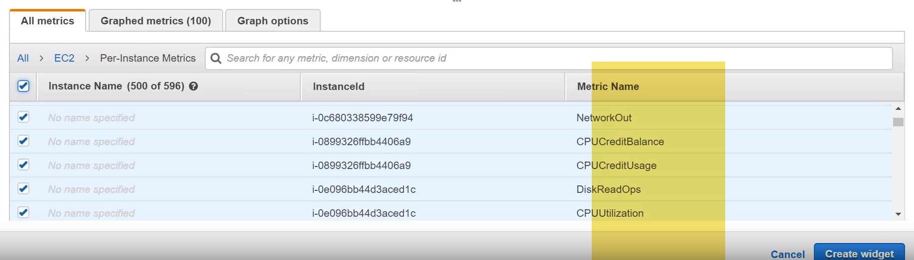

Metrics not showing anything(EC2 stopped state in demo)-🡪it needs a running instance and some data to be picked up. It is seen last one week what happens if I can trigger some charts okay… we have some amount of data to show some charts there .

-🡪you have to create your dashboard according to your customers needs. So if your customer wants to know how much you CPU credit…

UseCase: amount of data that you are having in your EBS..,how many snapshots you have… how much storage you have… when the snapshots.

you can use a combination of those things and then you can have a dashboard and give it to your monitoring team or you can configure an alarm based on that so you can have a alarms tied it to your dashboard

**-🡪If anybody wants to know what is happening in your account …they come to this dashboard and quickly see things …I want to modify or these are things that are causing more budget or billing… then I can go and monitor it or edit it or delete it.**

UseCase Ex:I want to show number odf objects in S3

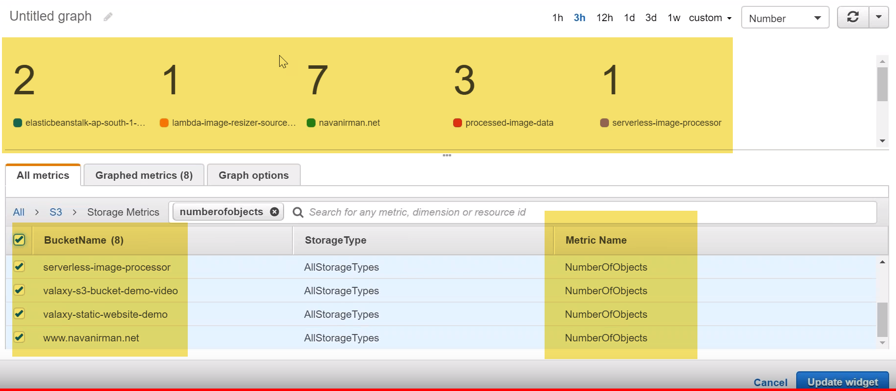

UseCase We also have size of bucket also…